Project Sprint Planning Notes

Team: 6

Sprint: 1

Date: 06/08/2021

Attended:

Scrum Master: Reylan Gill

Product Owner: Dipto Pratyaksa

Development team: Reylan Gill, Fraser Green, Hugh Phung, Sam Te, (Dipto Pratyaksa- customer)

1. Goal

In this sprint, the main goal is to build the foundations of the web application, enough to provide a visual indication of what it can accomplish. Some of the core functionalities will be attempted, such as home and single-book display. Doing this will enable the completion of transactions and orders.

1. Duration of the sprint

2 weeks

1. What is the team’s vision for this sprint?

User stories from the product backlog that will be focused on will relate to user site display, and perhaps dashboard features.

By the end of the sprint, we should have basic view and link functionalities in place with a visual layout of the web application.

1. Estimation in story points

**User Story:** As a customer I want to see an image of the book cover, so that I can appreciate the cover art

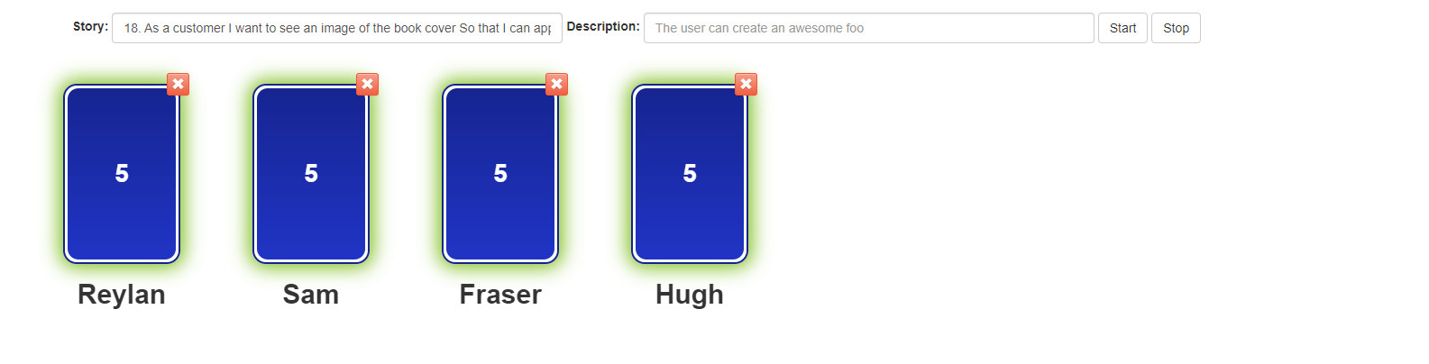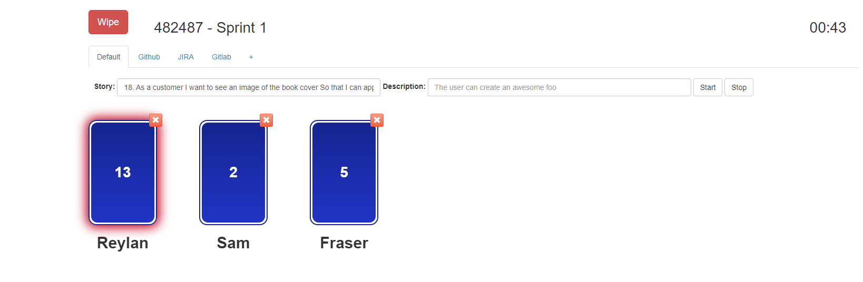

Reylan – Effort may be a result of the cumulative tasks required for the user story.

Sam & Fraser – Image display should be relatively easy once the foundations have been set.

Final effort decided upon was 5 due to the tasks required to be completed beforehand. Team concluded that since this was the first sprint, initial site foundations would be necessary.

**User Story:** As a first-time visitor, I want to land at a homepage with number of friendly links to useful pages, so that I can navigate the website

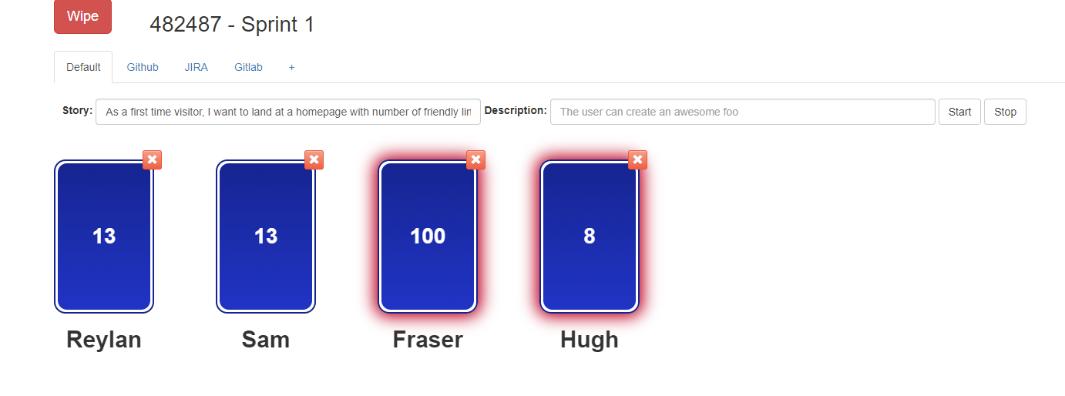

Fraser – In order to have a fully functional homepage, many of the site’s other functionalities must be completed especially in regard to data storage.

Team concluded that Fraser was correct in overestimating the effort required, as there may be extra functionalities to consider in practice.

**User Story:** As an admin, I want to be able to access a list of all current books in the system, So that I can add or edit new books.

This user story should be comparatively easier than the home page, with basic SQL data display.

**(less sql than homepage but a bit of work) reylan 20 13 13 8 fraser (few sql commands)**

**User Story:** As a user, I want to be able to go to a specific book's page to view more information about it, o that I know about the book being sold

Might also include more than just data display but also retrieval. Book page might also include other functionalities that will be incorporated in future sprints.

Team consensus for this user story: 8 effort points.